**PIZZA SALES SQL QUERIES**

**1. Total Revenue:**

SELECT SUM(total_price) AS Total_Revenue FROM pizza_sales;

**Output :-**

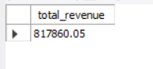

**2. Average Order Value**

SELECT (SUM(total_price) / COUNT(DISTINCT order_id)) AS Avg_order_Value FROM pizza_sales;

**Output :-**

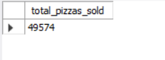

**3. Total Pizzas Sold**

SELECT SUM(quantity) AS Total_pizza_sold FROM pizza_sales;

**Output :-**

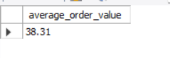

**4. Total Orders**

SELECT COUNT(DISTINCT order_id) AS Total_Orders FROM pizza_sales;

**Output :-**



**5. Average Pizzas Per Order**

select round(sum(quantity)/count(distinct order_id), 2) as average_pizza_per_order from pizza_sales;

**Output :-**

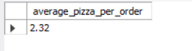

**6. Daily Trend for Total Orders**

select dayname(order_date) as order_day, count(distinct order_id) as total_orders_per_day from pizza_sales group by dayname(order_date)

 order by total_orders_per_day desc;

**Output :-**

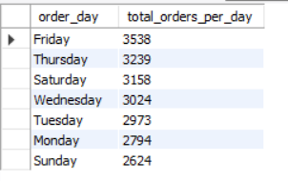

**7. Monthly Trend for Orders**

select monthname(order_date) as order_month, count(distinct order_id) as total_orders_per_month from pizza_sales group by monthname(order_date)

 order by total_orders_per_month desc;

**Output :-**

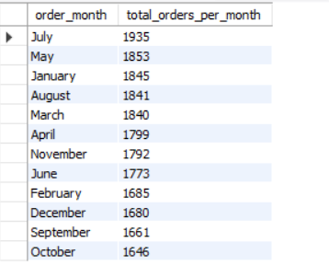

**8. % of Sales by Pizza Category**

 select pizza_category, round(100*sum(total_price)/(select sum(total_price) from pizza_sales), 2)

 as sales_percentage_of_each_category

 from pizza_sales group by pizza_category;

**Output :-**

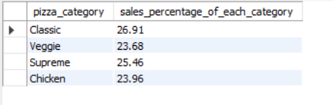

**9. % of Sales by Pizza Size**

  select pizza_size, round(100*sum(total_price)/(select sum(total_price) from pizza_sales), 2)

 as sales_percentage_of_each_size

 from pizza_sales group by pizza_size order by sales_percentage_of_each_size;

**Output :-**

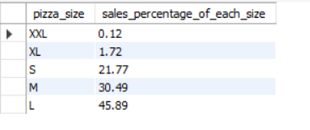

**10. Total Pizzas Sold by Pizza Category**

 select pizza_category, sum(quantity)

 as pizza_sold_categorywise

 from pizza_sales group by pizza_category;

**Output :-**

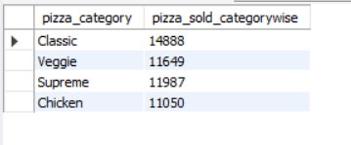

**11. Top 5 Pizzas by Revenue**

select pizza_name, round(sum(total_price), 2) as Revenue

 from pizza_sales group by pizza_name order by Revenue desc  limit 5;

**Output :-**

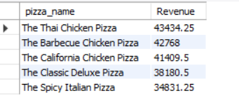

**12. Bottom 5 Pizzas by Revenue**

 select pizza_name, round(sum(total_price), 2) as Revenue

 from pizza_sales group by pizza_name order by Revenue asc  limit 5;

**Output :-**

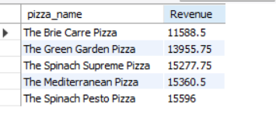

**13. Top 5 Pizzas by Quantity**

 select pizza_name, sum(quantity) as total_qty

 from pizza_sales group by pizza_name order by total_qty desc  limit 5;

**Output :-**

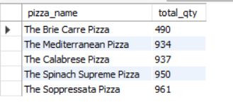

**14. Bottom 5 Pizzas by Quantity**

  select pizza_name, sum(quantity) as total_qty

 from pizza_sales group by pizza_name order by total_qty asc limit 5;

**Output :-**

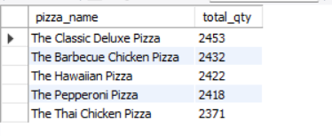

**15. Top 5 Pizzas by Total Orders**

 select pizza_name, count(distinct order_id) as total_orders

 from pizza_sales group by pizza_name order by total_orders desc  limit 5;

**Output :-**

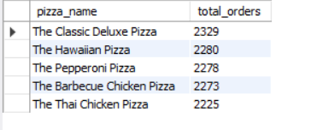

**16. Bottom 5 Pizzas by Total Orders**

  select pizza_name, count(distinct order_id) as total_orders

 from pizza_sales group by pizza_name order by total_orders asc  limit 5;

**Output :-**

